Scilab Practical-1 Laplace Transform

Sample Question

**Ques**: .Draw the surface plot of Laplace Transform of following function keeping s=σ+j ω

**Code:**

**Instructions**

**Make a word file in the following manner and upload the file in LMS Assignment.**

|  |  |  |
| --- | --- | --- |
| Steps | Details | Marks (25) |
| 1 (on the top of page) | Name  Batch & Roll no  Tutorial Name and date: T1- scilabpractical1 L.T. | 1 |
| 2 | File name :P1-RollNo-Batch no_Name  Eg.P1-16010421001-A1- TANUSHREE ACHARYA | 1 |
| 3 | Question1  Code  Output | 1  3  3 |
| 4 | Question2  Code  Output | 1  3  3 |
| 5 | Question3  Code  Output | 1  3  3 |
| 6 | Upload the file during practical period on LMS | 2 |

**Name: Tirth Patel**

**Batch: A3**

**Roll no: 16010421075**

**Tutorial Name and date: T1- scilabpractical1 L.T. 30/08/2022**

**Ques 1** Draw the surface plot of Laplace Transfrom of following function keeping s=σ+j ω

$$f\left(t\right)=\left\{\begin{aligned}e^{5t}\cos{(3t)} , 0< &t<5 \\ 0 , 5< &t\end{aligned}\right.$$

Code on Scinotes :

clear; clc;

t=0:0.01:5; *// function is defined in this range//*

f=exp(5*t).*cos((3*t));

a=1; *//variable chosen to define the loop for sigma //*

for sigma=-0.5:0.01:0.5, *//range for sigma is required to plot the graph, //*

b=1; *//variable chosen to define the loop for omega //*

for omega =-0.5:0.01:0.5,

rp=f.*exp(-sigma*t).*cos(omega*t); *//real part of integrand e^(-st) f(t)=e^(-(σ+j ω)t) f(t)//*

irp(a,b)=inttrap(t,rp); *//command to find integration of real part of integrand using trapezoidal rule//*

ip=f.*exp(-sigma*t).*sin(omega*t); *//imaginary part of integrand//*

iip(a,b)=inttrap (t,ip); *//command to find integration of imaginary part of integrand using trapezoidal rule//*

magnitude (a,b)=abs(irp(a,b)+%i*iip(a,b)); *//evaluation of integral including real and imaginary part//*

b=b+1; end;

a=a+1; end;

sigma=-0.5:0.01:0.5;

omega=-0.5:0.01:0.5;

plot3d(sigma,omega,magnitude) *// plot3d is to be used to plot 3 variables*

title('Tirth 16010421075 GRAPH1','fontsize',5)

**Output:** 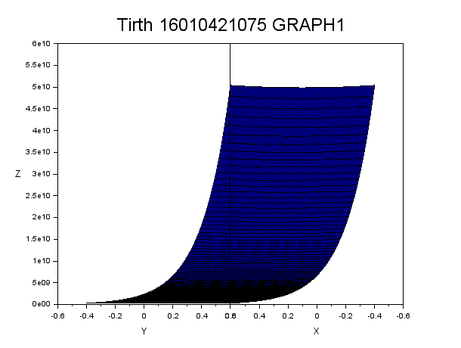

**Note: to paste the graph, click on copy to clipboard in file in graphic window and give the command paste here.**

Q.2 .Draw the surface plot of Laplace Transform of following functions keeping s as real $f\left(t\right)=\left\{\begin{aligned}cos⁡(4t), 0< &t<3 \\ 0 , 3< &t\end{aligned}\right.$

Code on Scinotes :

clear; clc;

t=0:0.01:3; *// function is defined in this range//*

f=cos(4*t);

a=1; *//variable chosen to define the loop for sigma //*

for sigma=-0.5:0.01:0.5, *//range for sigma is required to plot the graph, //*

rp=f.*exp(-sigma*t); *//real part of integrand e^(-st) f(t)=e^(-(σ+j ω)t) f(t)//*

irp(a)=inttrap(t,rp); *//command to find integration of real part of integrand using trapezoidal rule//*

magnitude(a)=abs(irp(a)); *//evaluation of integral including real and imaginary part//*

a=a+1; end;

sigma=-0.5:0.01:0.5;

plot2d(sigma,magnitude) *// plot2d is to be used to plot 3 variables*

title('Tirth 16010421075 GRAPH2','fontsize',5)

**Output:**

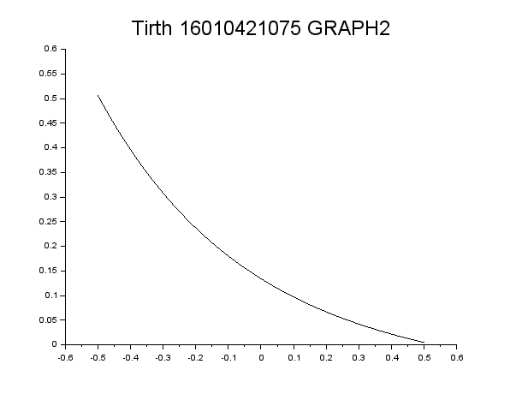

Q.3 Draw the surface plot of Laplace Transform of following functions keeping s imaginary

$$f\left(t\right)=\left\{\begin{aligned}sin⁡(2t) , 0< &t<4 \\ 0 , 4< &t\end{aligned}\right.$$

Code on Scinotes :

clear; clc;

t=0:0.01:4; *// function is defined in this range//*

f=sin(2*t);

b=1; *//variable chosen to define the loop for omega //*

for omega =-0.5:0.01:0.5,

rp=f.*cos(omega*t); *//real part of integrand e^(-st) f(t)=e^(-(σ+j ω)t) f(t)//*

irp(b)=inttrap(t,rp); *//command to find integration of real part of integrand using trapezoidal rule//*

ip=f.*sin(omega*t); *//imaginary part of integrand//*

iip(b)=inttrap (t,ip); *//command to find integration of imaginary part of integrand using trapezoidal rule//*

magnitude (b)=abs(irp(b)+%i*iip(b)); *//evaluation of integral including real and imaginary part//*

b=b+1; end;

omega=-0.5:0.01:0.5;

plot2d(omega,magnitude) *// plot3d is to be used to plot 3 variables*

title('Tirth 16010421075 Graph3','fontsize',5)

